AANDIYAANG LENDING

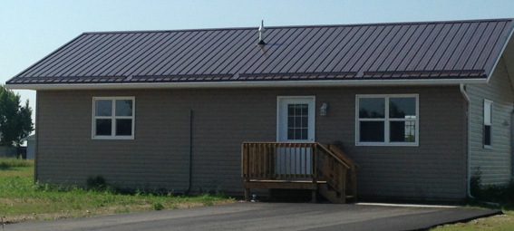

APPLICATIONS ARE STILL BEING TAKEN

6291 Hawk Crescent 6295 Hawk Crescent
Lot #: 71 Lot #: 72
Bedrooms: 3 Bedrooms: 3
Bathrooms: 1 Bathrooms: 1
Total Square Foot: 912 Sq.Ft. Total Square Foot: 912 Sq.Ft.
Asking Price: $145,901.00 Asking Price: $146,071.00
Appliances: 0 Appliances: 0
Lot Size: 0.311 acres Lot Size: 0.345 acres

ARE YOU ELIGIBLE TO APPLY?

- Must be a registered CKSPFN Band Member.
- Must be 18 years of age or older.
- No outstanding arrears within the First Nation.
- Stable employment. (minimum two years)
- TransUnion or Equifax credit check within the last 30 days- minimum score 600.
- Must be able to pay a down payment of 5%.

Contact Alison Price at Southwind Corporate Development Inc.
(519) 786-6753
Alison.Price@kettlepoint.org
9111 West Ipperwash Road. Unit #8, Kettle & Stony Point FN, N0N 1J

